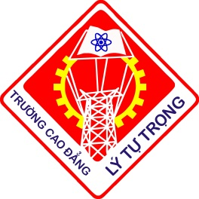
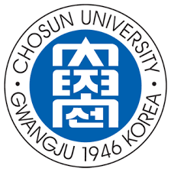

MEMORANDUM OF UNDERSTANDING

Between

LY TU TRONG COLLEGE
HO CHI MINH CITY
Address: 390 Hoang Van Thu, Ward 4, District Tân Bình,
Ho Chi Minh City, Vietnam

And

CHOSUN UNIVERSITY
KOREA
Address: 309 Pilmun-daero, Seonam-dong, Dong-gu, Gwangju,
Korea

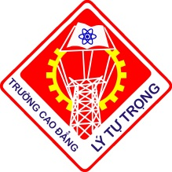

MEMORANDUM OF UNDERSTANDING
BETWEEN
LY TU TRONG COLLEGE HCMC, VIETNAM
AND
CHOSUN UNIVERSITY, KOREA

1. For the purpose of collaboration in both education and academic research, Chosun University (CU) and Ly Tu Trong College (LTTC) hereby affirm their intent to promote academic cooperation and exchange which will be of mutual benefit to their respective universities. Both Parties agree to encourage academic cooperation through research and study in the furtherance of learning and through the objectives stated below:

1.1 Academic staff cooperation on collaborative research, lectures and conferences in areas of common interests.
1.2 Exchange of lecturers and researchers.
1.3 Exchange of data, documentation and research materials in the field of mutual
interests.
1.4 Exchange of students, cultural and academic trip programs including credit transfer.
1.5 Exchange of academic information and publications.
1.6 Supporting of Korean Language Training.
1.7 Any other collaborative efforts that may be beneficial to both parties.

2. Collaborative activities or projects between the parties will be subject to further agreement detailing the parties' responsibilities and obligations and the conditions relating to each activity or project.

3. Both universities acknowledge that the visit by faculty from each Party one university to the other shall be subject to the entry and visa regulations of the Republic of Korea and the Socialist Republic of Vietnam and shall comply with the regulations and policies of each Party.

4. This Memorandum of Understanding shall come into effect on the date of signature by the Parties and show remain in force for the period of five (05) years and will be automatically renewed for similar period unless each Party gives the other a written note of its desire to terminate or to revise the Memorandum of Understanding six (6) months prior to the termination of a given five (5) year period.

5. This Memorandum is done in duplicate in Vietnamese and English, all texts being equally authentic. In any case of any divergence of interpretation, the English text shall prevall.

For CU  D.D.S.&Ph.D. Kang, Dong-Oan  President  Chosun University  Republic of Korea  Date: | For LTTC  Dr. Pham Huu Loc  Principal  Ly Tu Trong College HCMC  Socialist Republic of Viet Nam  Date:

